SIMATS ENGINEERING

ASSESSMENT TOOL 1

Experiments

NAME: Samuel V REG.NO:192412237
COURSE NAME: Computer Networks COURSE CODE: CSA0714

COURSE OUTCOME COVERED

CO3: Analyze the performance of core network protocols such as TCP, UDP, HTTP, and DNS under varying conditions
Assessment Tool Weightage: 40%
SOFTWARE: CISCO PACKET TRACER, WIRESHARK

EXPERIMENTS

QUESTIONS:4 Total Marks:40

- Design a simple LAN consisting of two PCs connected through a switch using Cisco Packet Tracer. Configure appropriate IP addresses for both hosts and verify connectivity using the ping command. Simultaneously capture the packet exchange using Wireshark. Identify the Ethernet frame fields such as Source MAC Address, Destination MAC Address, EtherType, and Frame Check Sequence (FCS). Explain how the Data Link layer uses MAC addressing to ensure successful frame delivery within the local network.
- Create a network topology consisting of two LANs connected through a router in Cisco Packet Tracer. Configure IPv4 addressing, subnet masks, and default gateways for all devices, and verify end-to-end communication using the ping command. Capture the ICMP packets using Wireshark and analyze the IPv4 header fields, including Source IP Address, Destination IP Address, Time-To-Live (TTL), Protocol Number, and Header Length. Explain the role of the Network layer in forwarding packets between different networks.
- Construct a local area network with multiple hosts connected through a switch in Cisco Packet Tracer. Clear the ARP cache on one of the hosts and initiate communication with another host using the ping command. Capture the communication in Wireshark and identify the ARP Request and ARP Reply packets. Analyze the sender and target MAC/IP addresses and explain how the Address Resolution Protocol resolves logical IP addresses into physical MAC addresses before data transmission.
- Develop a simple network consisting of two PCs connected through a router in Cisco Packet Tracer. Configure the required IP addresses and test connectivity using the ping command. Capture the ICMP traffic using Wireshark and identify the Echo Request and Echo Reply messages. Examine important ICMP fields such as Type, Code, Identifier, and Sequence Number, and calculate the Round Trip Time (RTT). Discuss how ICMP assists in network troubleshooting and connectivity verification.

- Create a client-server network in Cisco Packet Tracer by configuring a web server and a client PC. Enable the HTTP service on the server and access the hosted webpage from the client using a web browser. Capture the communication in Wireshark and identify the TCP three-way handshake, followed by the HTTP GET request and HTTP response messages. Analyze the application-layer communication and explain how TCP provides reliable delivery for HTTP traffic through connection establishment, acknowledgments, and ordered data transfer.
RUBRICS FOR CALCULATION

Criteria | Weightag  e | Level 4 –  Exemplary | Level 3 –  Proficient | Level 2 –  Developing | Level 1 –  Beginning
Understandin g of Concepts | 25 | Demonstrates thorough understanding and effectively integrates multiple concepts/technologi  es | Good understanding with proper integration of most  concepts | Basic understanding  ; limited or partial integration | Poor understanding  ; unable to integrate concepts
Experimental Design | 30 | Well-planned, systematic implementation with optimal  solution | Correct implementati on with minor issues | Basic implementati on with errors or  inefficiencies | Incorrect or incomplete implementati on
Use of Tools | 20 | Effective and advanced use of tools/technologies with proper  configuration | Appropriate use of tools with correct execution | Limited or inconsistent use of tools | Incorrect or minimal use of tools
Analysis of Results | 15 | Insightful analysis with accurate interpretation and  validation of results | Good analysis with reasonable  interpretation | Basic analysis with limited  insights | Poor or incorrect analysis of  results
Documentati on | 10 | Clear, well-structured documentation with diagrams, code, and  results | Organized documentatio n with necessary  details | Basic documentatio n with missing  details | Poor or incomplete documentatio n

- Construct a local area network with multiple hosts connected through a switch in Cisco Packet Tracer. Clear the ARP cache on one of the hosts and initiate communication with another host using the ping command. Capture the communication in Wireshark and identify the ARP Request and ARP Reply packets. Analyze the sender and target MAC/IP addresses and explain how the Address Resolution Protocol resolves logical IP addresses into physical MAC addresses before data transmission.

AIM

To construct a Local Area Network (LAN) with multiple hosts connected through a switch, configure IP addresses, clear the ARP cache of a host, initiate communication using the ping command, and capture and analyze the ARP Request and ARP Reply packets using Wireshark to understand how IP addresses are resolved into MAC addresses.

PROCEDURE
- Construct the LAN topology by connecting multiple PCs to a switch in Cisco Packet Tracer.
- Configure IP addresses for all PCs in the same network.
- Verify the network configuration and ensure that all devices are connected properly.
- Clear the ARP cache of the source PC so that a new ARP resolution process is triggered.
- Initiate communication using the ping command from one PC to another.
- Capture the communication using Wireshark and identify the ARP Request and ARP Reply packets.
- Analyze the ARP packets by examining the sender/target MAC and IP addresses and explain how ARP resolves an IP address into a MAC address.

STEP-BY-STEP IMPLEMENTATION

Screenshot 1: Construct the LAN Topology
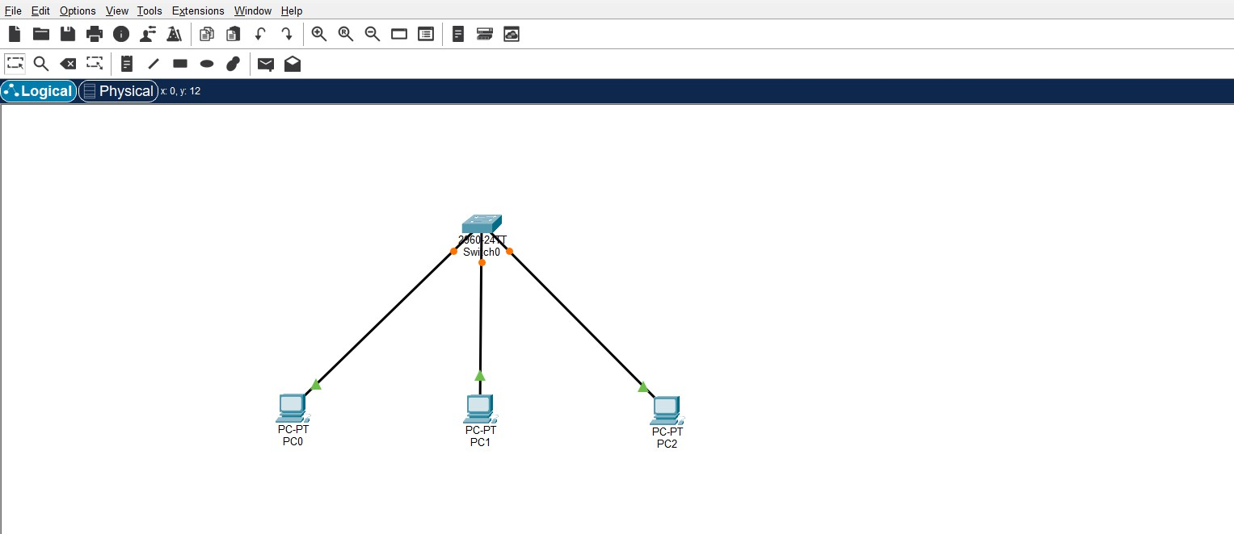

Figure 1:construction of LAN

Parameter Table

Parameter | Value
Network Type | LAN

Number of PCs | 3
Network Device | Switch
Switch Type | 2960
Connection | Copper Straight-Through
Topology | Star
Communication | Ethernet
Protocol to be analyzed | ARP

Explanation
This screenshot shows the construction of a Local Area Network using multiple hosts connected to a central switch.
The switch provides connectivity between the PCs within the same LAN. Since all PCs are connected to the same switch and will be configured in the same IP subnet, they can communicate directly without requiring a router.
The switch uses the MAC addresses of the connected devices to forward Ethernet frames to the appropriate destination.

STEP 2 — Assign IP Addresses to the PCs
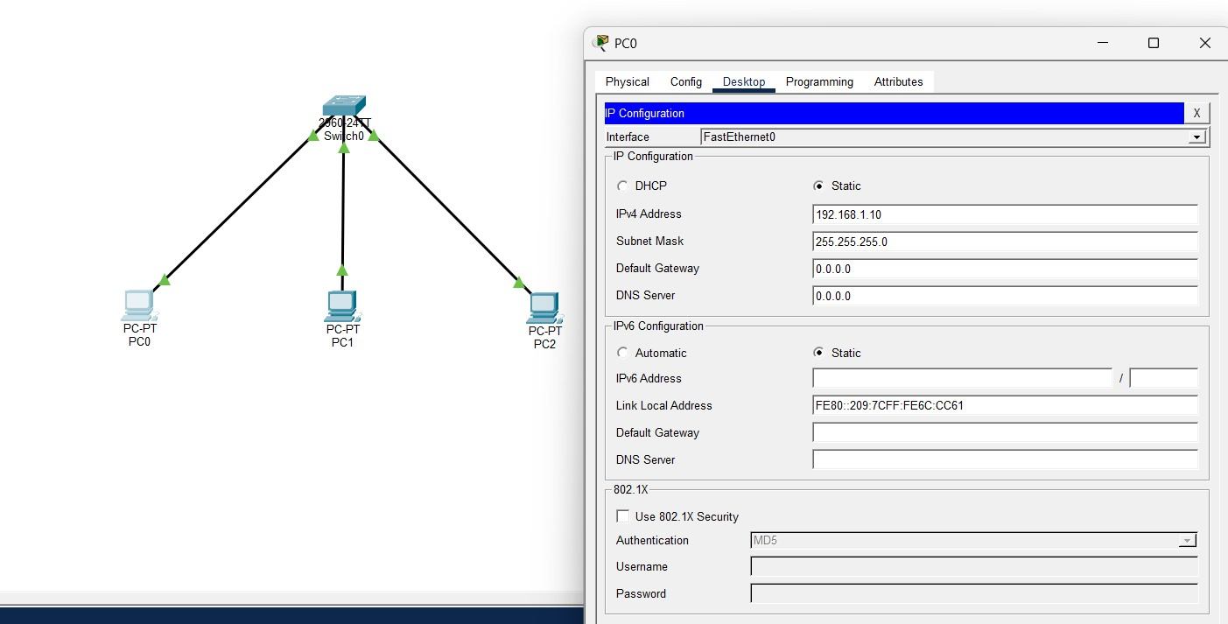
FIGURE 2:SUCCESSFULLY ASSIGNED THE IP ADDRESS TO THE PC0

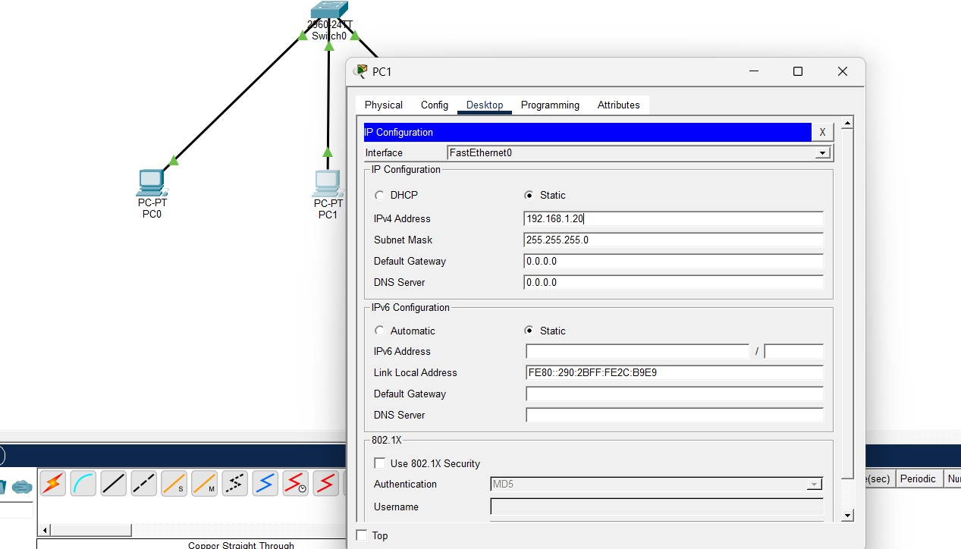
FIGURE 3: SUCCESSFULLY ASSIGNED THE IP ADDRESS TO THE PC 1
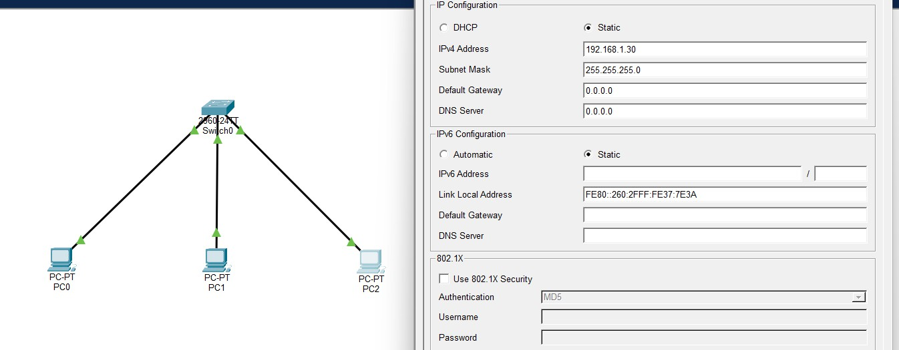
FIGURE 4: SUCCESSFULLY ASSIGNED THE IP ADDRESS TO THE PC 2
Parameter Table
Parameter | PC0
IPv4 Address | 192.168.1.10
Subnet Mask | 255.255.255.0
Default Gateway | Not required
Network Address | 192.168.1.0
Host Address | 10
Protocol | IPv4

Explanation
The PCs are assigned unique IP addresses belonging to the same network: 192.168.1.0/24
The /24 subnet mask means that the first three octets identify the network and the last octet identifies the host.
Therefore:
PC0 → 192.168.1.10
PC1 → 192.168.1.20
PC2 → 192.168.1.30

All three PCs are members of the same logical network.

STEP 3 — Verify Connectivity and ARP Table
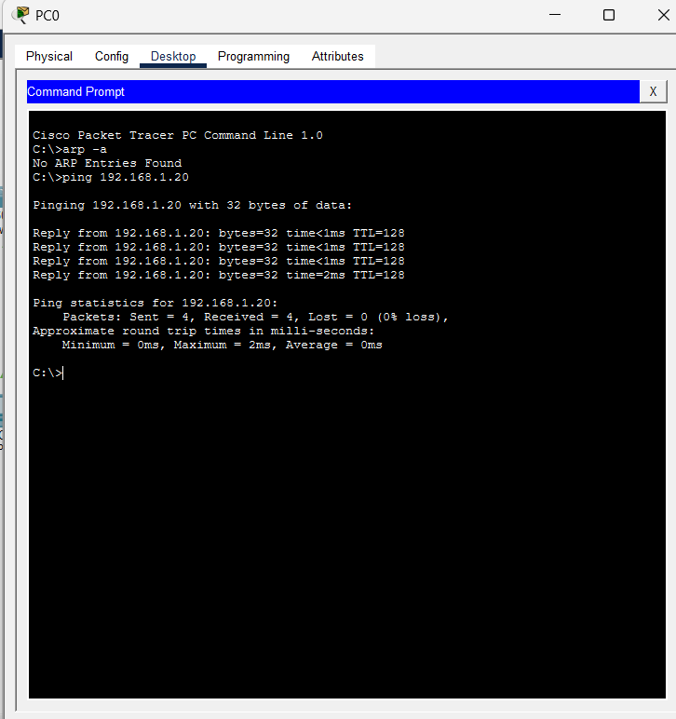

Figure 5: Successfully pinging the pc0 to pc1 Parameter Table
Parameter | Value
Source | PC0
Source IP | 192.168.1.10
Destination | PC1
Destination IP | 192.168.1.20
Command | arp -a
Purpose | Display ARP cache

Explanation
The ARP cache contains mappings between IP addresses and MAC addresses. For example, an entry may conceptually look like:
192.168.1.20 → 00:xx:xx:xx:xx:xx
This means PC0 has already learned the physical MAC address associated with PC1's IP address.

STEP 4:Clear ARP / Prepare for a New ARP Request

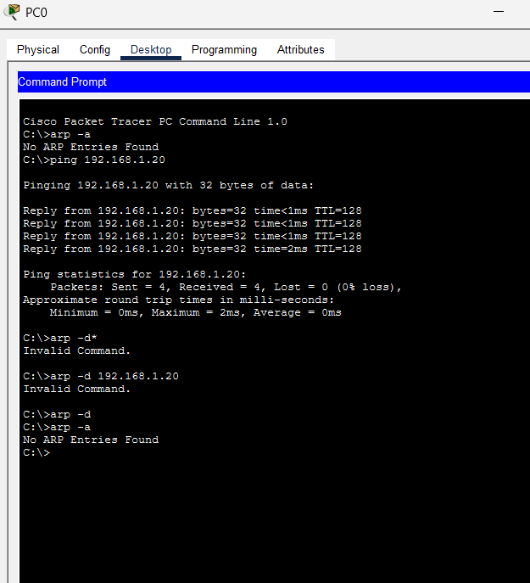

FIGURE 6:CLEARING PREVIOUS ARP

STEP 5 — Send the Ping
Open:
PC0 → Desktop → Command Prompt
Type:
ping 192.168.1.20
Now look at the Simulation Event List. You should see an ARP packet.

STEP5: Verifying the Updated ARP Cache
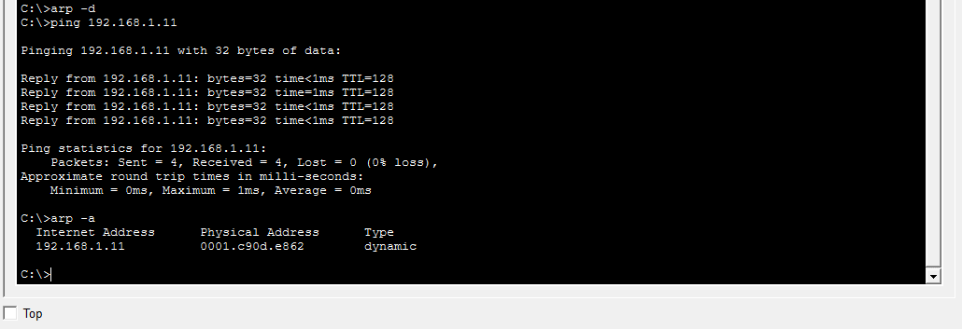
FIGURE7: Verifying the updated ARP cache on PC0 C:\> arp -a

Short Result
Interface: 192.168.1.1 --- 0x1 Internet Address Physical Address Type 192.168.1.2 0060.2f5b.4d6e dynamic

Explanation / Discussion
This final verification step confirms that the ARP transaction actually succeeded and persisted in memory, closing the loop that began with Command 1's deliberate cache flush. The single dynamic entry mapping 192.168.1.2 to 0060.2f5b.4d6e is exactly the information carried in the ARP Reply's Sender fields, proving that PC0 correctly parsed and stored the response. The entry is marked “dynamic” (as opposed to “static”) because it was learned automatically through the ARP protocol and is therefore subject to an aging timer; if no traffic is exchanged with PC1 for the cache's timeout duration, the entry will expire and a

fresh ARP Request/Reply cycle will be required the next time PC0 needs to reach 192.168.1.2. Practically, this caching behavior is what makes subsequent pings, file transfers, or any further communication with PC1 faster — PC0 can now build Ethernet frames for PC1 immediately, without repeating the broadcast discovery process, until the entry is cleared or expires.

Wireshark / Simulation Capture
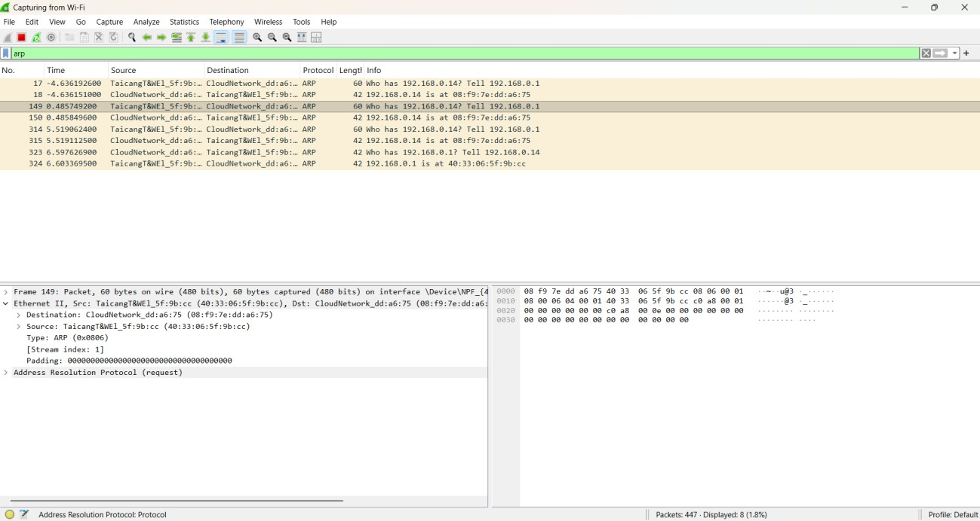

Figure 8: Wireshark capture showing ARP Request and ARP Reply frames
Command 1 — Clearing the ARP Cache

Command 1: Clearing the ARP cache on PC0

Command 2 — Analyzing the ARP Request Packet
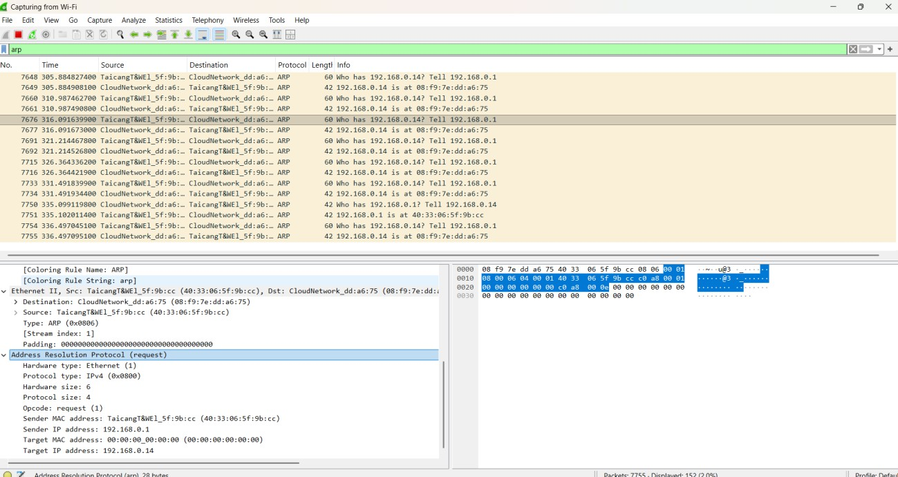
FIGURE 9: Inspecting the ARP Request packet fields Short Result (from PDU / Wireshark inspection)
Frame: Ethernet II, Broadcast Source MAC: 0060.2F3A.1B2C (PC0) Destination MAC: FFFF.FFFF.FFFF (Broadcast) Protocol: ARP Opcode: 1 (Request) Sender MAC: 0060.2F3A.1B2C Sender IP: 192.168.1.1 Target MAC: 0000.0000.0000 (Unknown) Target IP: 192.168.1.2

Explanation / Discussion
The ARP Request frame is addressed to the Ethernet broadcast address FF:FF:FF:FF:FF:FF

because PC0 has no way of knowing, in advance, which physical port or host on the LAN owns the IP address 192.168.1.2. Rather than guessing, ARP relies on a one-to-many broadcast so that every device on the local segment can inspect the request. Structurally, the packet's Sender fields (MAC 0060.2F3A.1B2C, IP 192.168.1.1) identify PC0 as the originator, while the Target IP field (192.168.1.2) specifies who must respond; the Target MAC field is deliberately left as 00:00:00:00:00:00 because that is precisely the unknown value being requested. At the switch, this broadcast frame is flooded out of every port except the one it arrived on (standard Layer 2 flooding behavior for broadcast/unknown-destination frames), which is why PC2 also receives a copy even though the request is not meant for it. PC2 compares the Target IP field against its own configured IP (192.168.1.3), finds no match, and silently discards the frame — only PC1 will continue processing it. This step illustrates ARP's fundamental request mechanism: a controlled broadcast used sparingly and only when a mapping is genuinely unknown.

Command 4 — Analyzing the ARP Reply Packet


FIGURE 10: Inspecting the ARP Reply packet fields Short Result (from PDU / Wireshark inspection)
Frame: Ethernet II, Unicast Source MAC: 0060.2F5B.4D6E (PC1) Destination MAC: 0060.2F3A.1B2C (PC0) Protocol: ARP Opcode: 2 (Reply) Sender MAC: 0060.2F5B.4D6E Sender IP: 192.168.1.2 Target MAC: 0060.2F3A.1B2C Target IP: 192.168.1.1

Explanation / Discussion
Unlike the request, the ARP Reply is never broadcast — it is sent as a direct, unicast Ethernet frame addressed specifically to PC0's MAC address (0060.2F3A.1B2C), because PC1 already learned that address from the Sender MAC field of the incoming request. The Opcode value changes from 1 (Request) to 2 (Reply), signalling to the receiving stack that this frame answers a prior query rather than initiating one. PC1 now populates the Sender fields with its own identity (MAC 0060.2F5B.4D6E, IP 192.168.1.2) and copies PC0's information into the Target fields, effectively reversing the roles from the request packet. This targeted, one-to-one delivery is more efficient than a second broadcast would be, since only the original requester needs the information.

Overall Result and Discussion
The experiment successfully demonstrated the complete ARP resolution process within a switched LAN, from an empty cache through to a fully populated one, and ties directly back to the five commands executed above. Initially, with PC0's ARP cache deliberately emptied (Command 1), the host had no record of any IP-to-MAC mapping on the network. When the

ping command was issued (Command 2), the operating system could not immediately transmit an ICMP Echo Request because it lacked the destination's physical address — this is the critical dependency that the whole experiment is designed to expose: Layer 3 communication cannot occur without Layer 2 addressing information, and ARP is the mechanism that bridges this gap on demand.
Analysis of the captured frames (Commands 3 and 4) showed the two halves of the ARP transaction behaving exactly as the protocol specifies:
PC0 broadcast an ARP Request (Opcode 1) asking “Who has 192.168.1.2? Tell 192.168.1.1,” addressed to the Ethernet broadcast MAC FF:FF:FF:FF:FF:FF, which the switch flooded out of every port except the source port.
Every host on the segment, including PC2, received and inspected the frame, but only PC1
— whose IP matched the Target IP field — continued processing it; PC2 discarded it silently.
PC1 replied with a unicast ARP Reply (Opcode 2) addressed directly to PC0's MAC address, embedding its own MAC/IP pair in the Sender fields so PC0 could learn it in a single exchange.
PC0 immediately cached this mapping (Command 5) and released the four queued ICMP Echo Requests, all of which received replies with 0% packet loss (Command 2 result).
This sequence confirms several important properties of ARP as a protocol: it operates strictly at the boundary between Layer 3 (IP) and Layer 2 (Ethernet/MAC); it is invoked reactively, only when the required mapping is absent from the local cache, rather than continuously; it uses a broadcast-then-unicast pattern that balances the need to reach an unknown host against the inefficiency of broadcasting the reply as well; and it is stateful, since the learned mapping is cached and reused for subsequent frames rather than being re-requested for every packet. The experiment also highlighted the practical role of the switch, which does not participate in the ARP resolution logic itself but is responsible for correctly flooding the broadcast frame and later forwarding the unicast reply to the correct port based on its MAC address table, ensuring the entire exchange completes within a switched environment rather than requiring a hub-style shared medium.

Conclusion
The Address Resolution Protocol (ARP) is essential for enabling communication in an IP-based Ethernet LAN, as it bridges the gap between logical addressing (IP) used by the Network layer and physical addressing (MAC) used by the Data Link layer. By clearing the ARP cache and observing a fresh ping exchange, it was demonstrated that a host must first discover a destination's MAC address via a broadcast ARP Request before any unicast data (such as ICMP packets) can be transmitted. The corresponding ARP Reply, sent as a unicast frame, completes this resolution and allows the ARP cache to be populated for efficient future communication.

- Develop a simple network consisting of two PCs connected through a router in Cisco Packet Tracer. Configure the required IP addresses and test connectivity using the ping command. Capture the ICMP traffic using Wireshark and identify the Echo Request and Echo Reply messages. Examine important ICMP fields such as Type, Code, Identifier, and Sequence Number, and calculate the Round Trip Time (RTT). Discuss how ICMP assists in network troubleshooting and connectivity verification.

Aim:
To develop a simple network consisting of two PCs connected through a router in Cisco Packet Tracer, configure the required IP addresses, and verify connectivity using the ping command. The ICMP Echo Request and Echo Reply packets are captured and analyzed in Wireshark by examining fields such as Type, Code, Identifier, Sequence Number, and Round Trip Time (RTT).

Procedure:
- Create a topology with two PCs and one router in Cisco Packet Tracer and connect them using Ethernet cables.
- Configure IP addresses, subnet masks, and default gateways for both PCs and the router interfaces.
- Use the ping command from one PC to the other to verify network connectivity.
- Start Wireshark and capture the ICMP traffic generated by the ping operation.
- Apply the icmp filter in Wireshark and identify the Echo Request (Type 8) and Echo Reply
(Type 0) packets.
- Examine the Type, Code, Identifier, Sequence Number, and packet timestamps to determine the RTT.
- Analyze the results and explain how ICMP helps in connectivity verification and network troubleshooting.

Implementation-1:
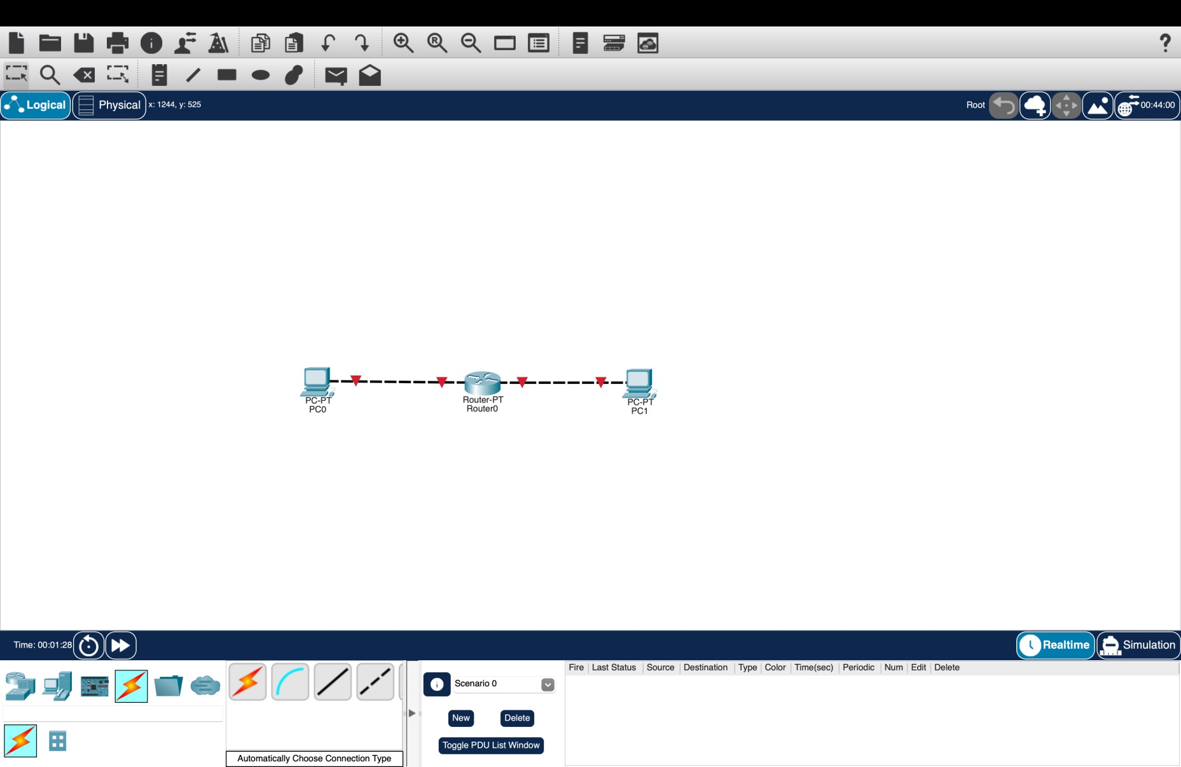
Fig1:Network Topology with Two PCs Connected Through a Router

Explanation:
The figure shows a simple network topology created in Cisco Packet Tracer, consisting of two PCs (PC0 and PC1) connected through a router (Router0). PC0 is connected to one interface of the router, while PC1 is connected to another interface. The router acts as an intermediary device that forwards data packets between the two PCs and their respective networks. The red link indicators show that the interfaces are currently down, so the router interfaces need to be configured and enabled before communication can take place.

Implementation-2:
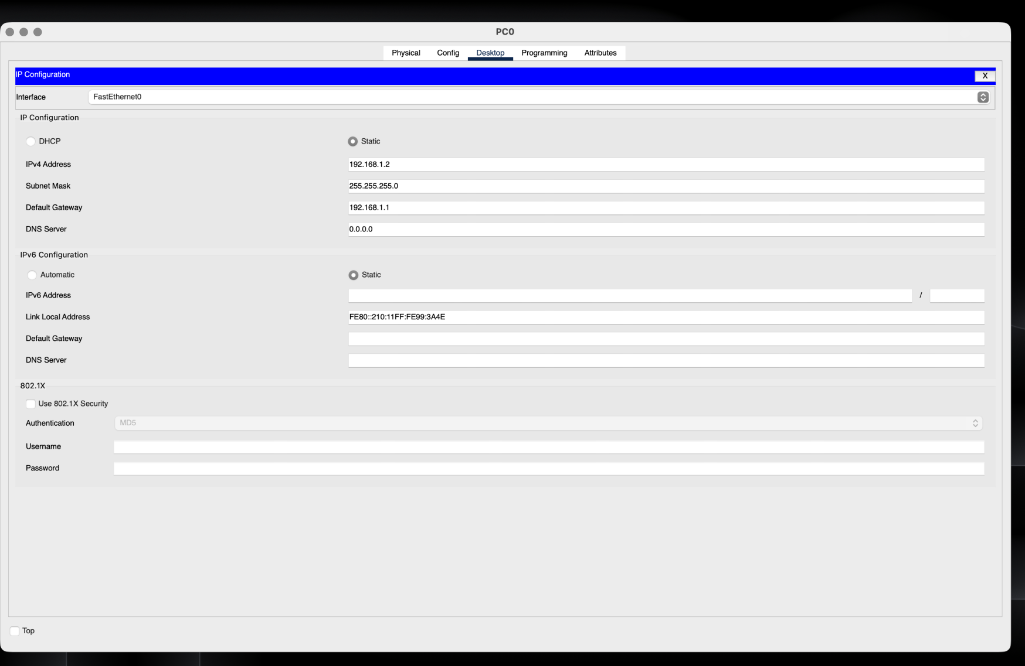
Fig2:IPAddress Configuration of PC0

Explanation:
The figure shows the IPv4 configuration of PC0 in Cisco Packet Tracer. A static IP address of 192.168.1.2 is assigned with the subnet mask 255.255.255.0. The default gateway is configured as 192.168.1.1, which is the router interface connected to PC0. This configuration allows PC0 to communicate with the router and access devices on other networks through the router.

Implementation-3:
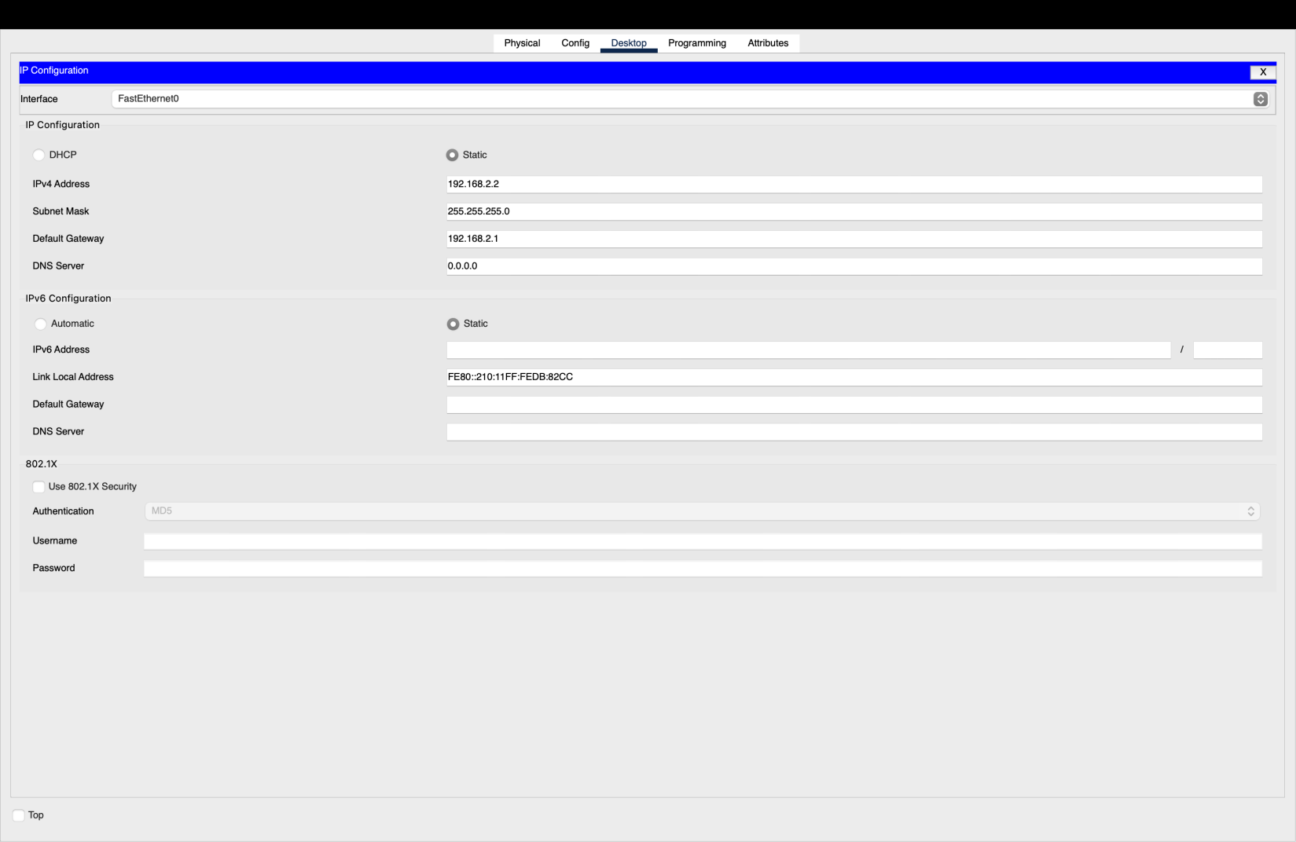

Figure 3: IP Address Configuration of PC1

Explanation:
The figure shows the IPv4 configuration of PC1 in Cisco Packet Tracer. PC1 is assigned the static IP address 192.168.2.2 with the subnet mask 255.255.255.0. The default gateway is configured as 192.168.2.1, which is the router interface connected to PC1. This configuration allows PC1 to communicate with the router and with devices on other networks.

Implementation-4:
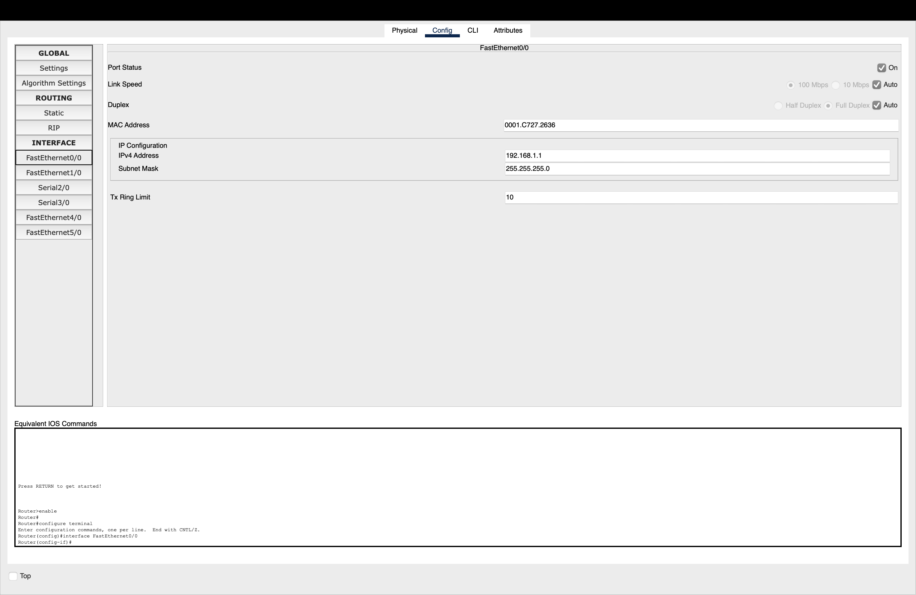
Figure 4: Router Interface Configuration for PC0 Network

Explanation:
The figure shows the configuration of FastEthernet0/0 on Router0. The interface is enabled and assigned the IP address 192.168.1.1 with subnet mask 255.255.255.0. This interface acts as the default gateway for PC0 (192.168.1.2) and connects PC0's network to the router.

Implementation-5:
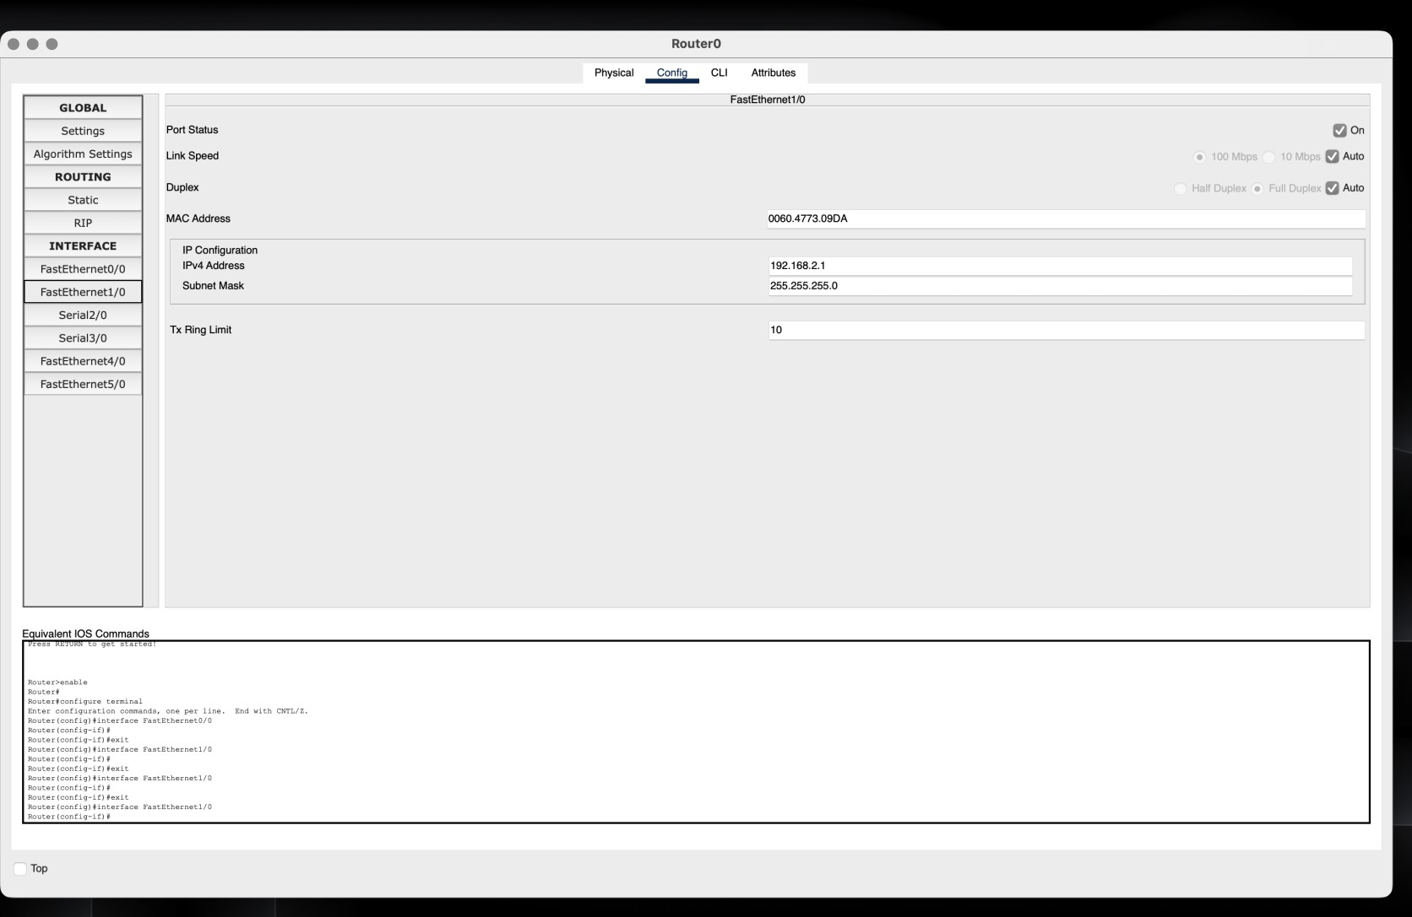
Fig5:RouterInterface Configuration for PC1 Network

Explanation:
The figure shows the configuration of FastEthernet1/0 on Router0. The interface is enabled and assigned the IP address 192.168.2.1 with subnet mask 255.255.255.0. This interface acts as the default gateway for PC1 (192.168.2.2) and connects PC1's network to the router.

Implementation-6:
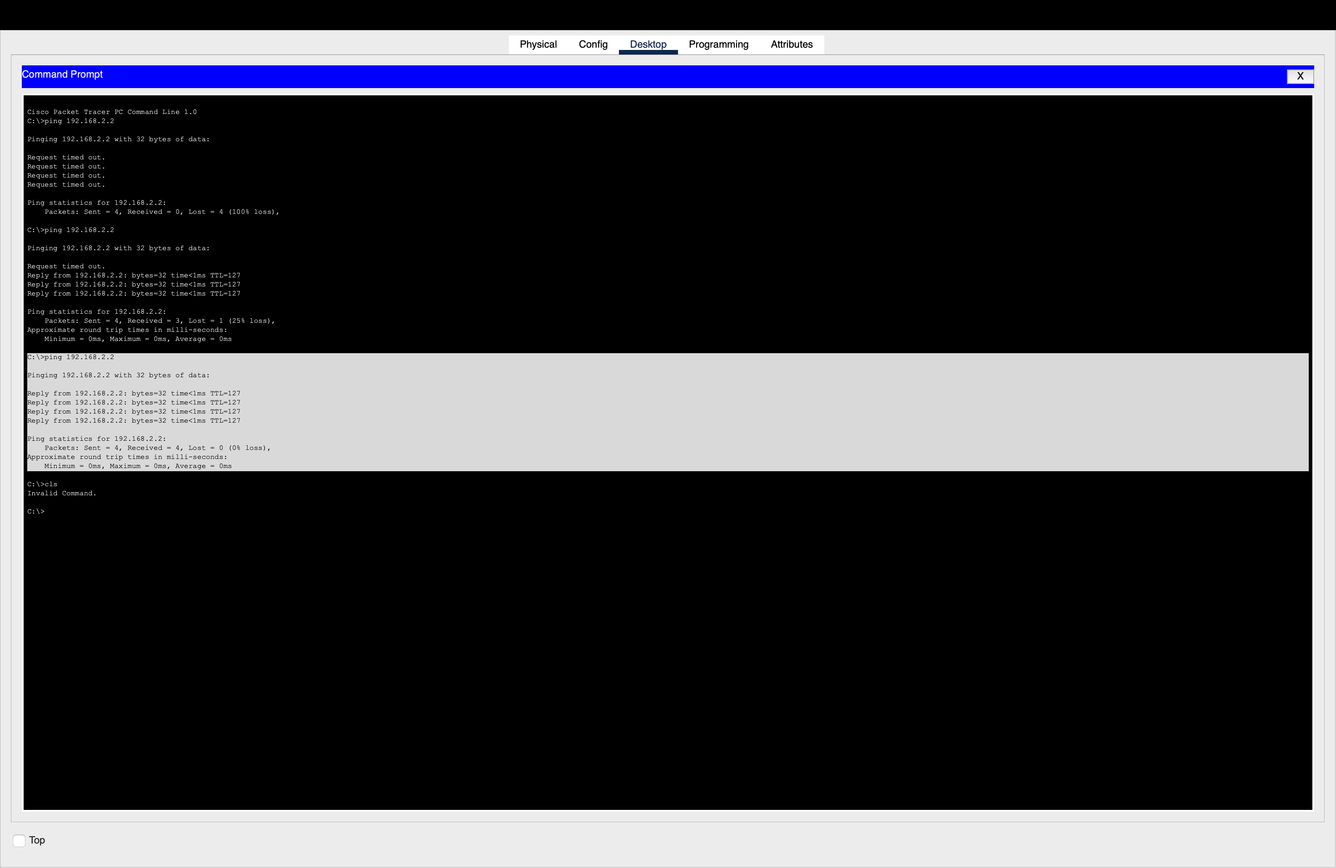

Figure 6: Successful Ping Connectivity Between PC0 and PC1

Device | Interface | IP Address | Subnet Mask | Default Gateway
PC0 | FastEthernet0 | 192.168.1.2 | 255.255.255.0 | 192.168.1.1
Router0 | FastEthernet0/0 | 192.168.1.1 | 255.255.255.0 | —
Router0 | FastEthernet1/0 | 192.168.2.1 | 255.255.255.0 | —
PC1 | FastEthernet0 | 192.168.2.2 | 255.255.255.0 | 192.168.2.1

Explanation:
The ping 192.168.2.2 command was successfully executed from PC0 to PC1 through the router. All four ICMP packets received replies, resulting in 0% packet loss. This confirms that the IP configuration and routing between the two PCs are working correctly.

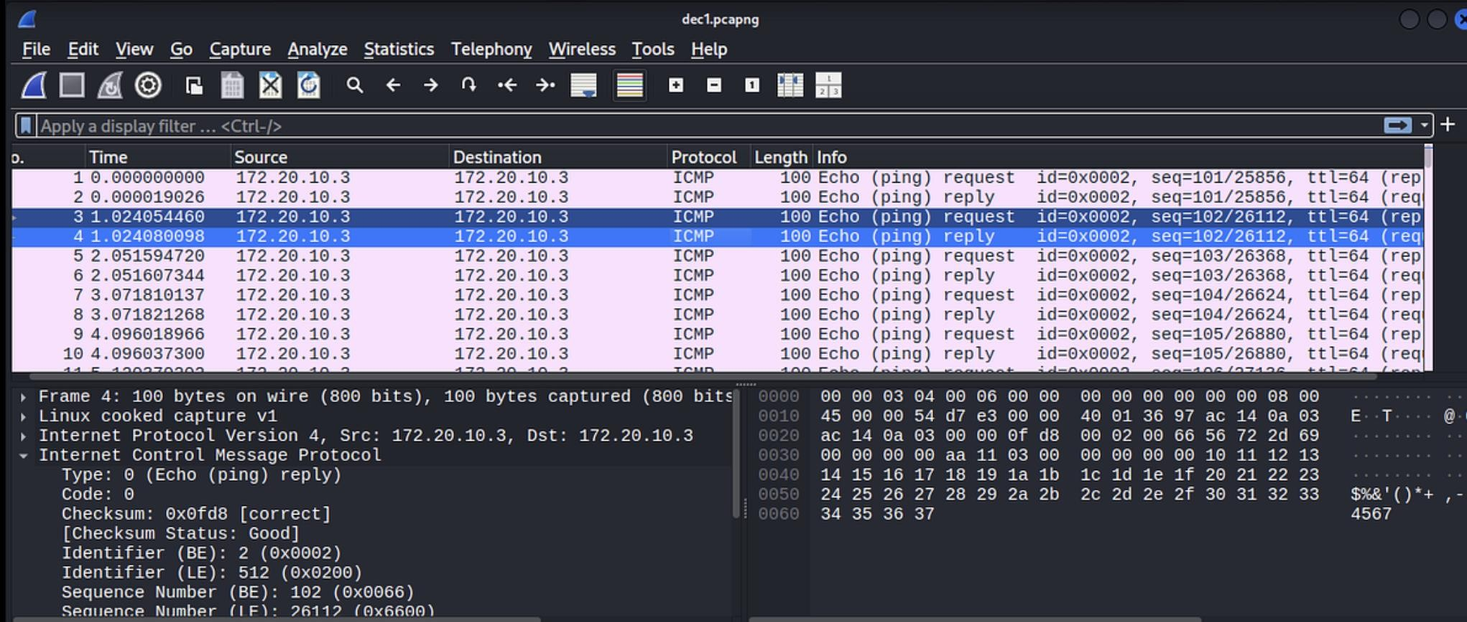

Implementation-7:
Figure 7: Wireshark Capture Showing ICMP Echo Request and Echo Reply Packets

ICMP Field | Echo Request | Echo Reply | Explanation
Type | 8 | 0 | Type 8 represents Echo Request and Type 0 represents Echo Reply.
Code | 0 | 0 | Code 0 indicates a normal ICMP echo message.
Identifier | Same value | Same value | Identifies the ping process and matches the request with its reply.
Sequence Number | 0, 1, 2, 3... | Same number | Identifies the individual ping request and its corresponding reply.

ICMP in Network Troubleshooting and Connectivity Verification:
ICMP helps network administrators check whether devices are reachable and communicating correctly. The ping command uses ICMP Echo Request and Echo Reply messages to verify connectivity between two devices. It also provides information about packet loss and Round Trip Time (RTT), which helps identify network delays or failures. ICMP error messages can indicate problems such as unreachable hosts or networks. Therefore, ICMP is useful for detecting connectivity issues, measuring response time, and troubleshooting network communication.

